**18CSC305J: ARTIFICIAL INTELLIGENCE**

***EX8- IMPLEMENTATION OF KNOWLEDGE REPRESENTATION SCHEMES- SUDOKU SOLVER***

**AIM:** To implement a use case of knowledge representation scheme (sudoku puzzle solver) using Python.

**ALGORITHM:**

* Knowledge Representation and Reasoning (**KR, KRR**) represents information from the real world for a computer to understand and then utilize this knowledge to solve **complex real-life problems.**
* An answer set program consisting of given knowledge formulated as facts, rules or constraints is entered:
  + Grid is defined to contain 9 rows and columns.
  + Each field is defined to contain only one number from 1-9.
  + Helper function to check for recurrences in the subgrid
  + Constraints: one occurrence of each number in a field and the respective subgrid.
* The program is loaded by a solver and returns an answer set.
* This set consists of all facts that can be derived using the given rules and constraints.
* A finite number of such sets are generated as solutions, of which one is finally selected.

**CODE:**

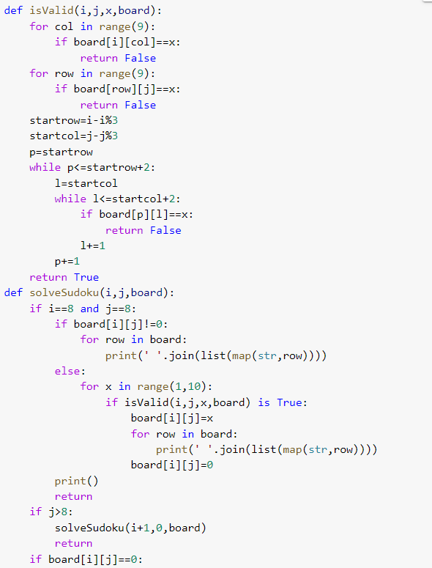

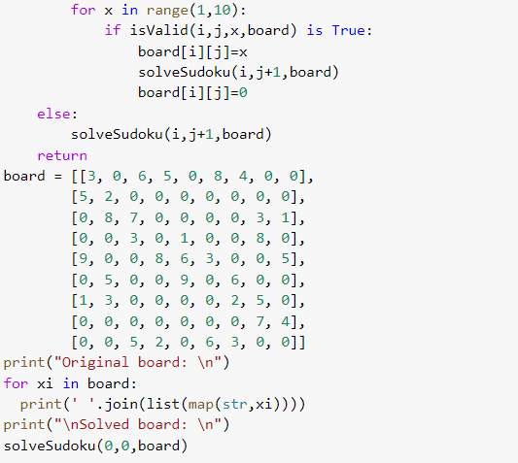

**OUTPUT:**

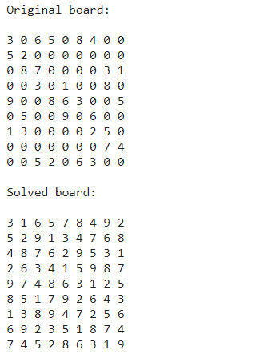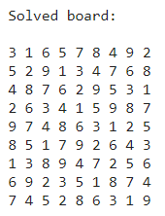

**RESULT:** The code for implementing knowledge representation scheme (sudoku puzzle solver) was written and executed in Python successfully.